Features
● Fully compliant with PCI Express Base Specification Revision 2.0
● Single-lane (x1) PCI Express throughput rates up to 5 Gbps
● Compliant with Universal Serial Bus 3.0 specification Revision 1.0
● Supports simultaneous operation of multiple USB 3.0, USB 2.0 and USB 1.1 devices
● Supports the following speed data rates as follows:
● Low-speed (1.5Mbps)/Full-speed (12Mbps)/High-speed(480Mbps) / Super-speed (5Gbps)
● Supports 2 or 4 downstream ports for all speeds
● Built-in 15-pin power connector for receiving extra power supply from system
● Hot-swapping feature allows you to connect/disconnect devices without powering down the system
● Support Windows® XP/Vista/7/8/8.1/10 (32/64 bit)

System Requirements
● Windows® XP/Vista/7/8/8.1/10 (32/64 bit)
● One available PCI Express slot (Recommend PCI Express 2.0)

Package Contents
● 1 x USB 3.0 PCI Express Card
● 1 x Software Drivers CD
● 1 x Low Profile Bracket (4 Port PCI Express Card without Low Profile Bracket)

Note: Contents may vary depending on country/market.
Hardware Installation

1. Turn Off the power to your computer.
2. Unplug the power cord and remove your computer’s cover.
3. Remove the slot bracket from an available PCIe slot.
4. To install the card, carefully align the card’s bus connector with the selected PCIe slot on the motherboard. Push the board down firmly.
5. Replace the slot bracket’s holding screw to secure the card.
6. Replace the computer cover and reconnect the power cord.

Driver Installation <For Windows® XP/Vista/7 (32/64 bit)>
1. Please insert the CD driver bound with USB 3.0 PCI Express Card into your CD-ROM Drive.
2. At the Windows desktop, click Start, Run.
3. Type D: \RENESAS-USB3-Host-Driver-30230-setup.exe, click OK. (Change D: to match your CD-ROM drive letter)
4. Follow the on-screen instructions to complete the installation.

To Verify Driver Installation
Click on the “Device Manager” tab in System Properties, which you access from the Windows Control Panel. You should see a “Renesas Electronics USB 3.0 Host Controller” under the “Universal Serial Bus controllers” item.

Notice:
1.Please make sure the power cable strand colours match each other when connecting to the power augmentation, as to avoid faulty currents.
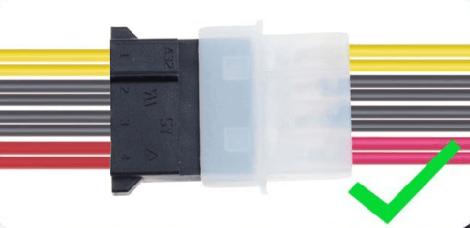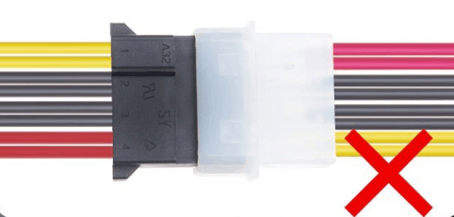
The correct connection way The incorrect connection way

2.The extended compatibility works better if insert the card in the first slot or the 16X slot.

